**Institute of Engineering & Management**

**Department of Computer Science & Engineering**

**Object Oriented Programming (IT) Lab for 3rd year 5th semester 2018**

**Code: CS594D**

**Date:** 10/7/18

**WEEK-1**

**Assignment-1**

**Problem Statement:** Write a Java program to print n number of Fibonacci numbers

**Source code:** class fibo  
{  
 public static void main(String[] args)  
 {  
 int f1=0, f2=1, temp, count=Integer.parseInt(args[0]);  
 System.out.print("Fibonacci numbers are : ");  
 for(int i=0;i<count;i++)  
 {  
 System.out.print(f1+", ");  
 temp = f1;  
 f1 = f2;  
 f2 = temp + f2;  
 }  
 System.out.println();  
 }  
}

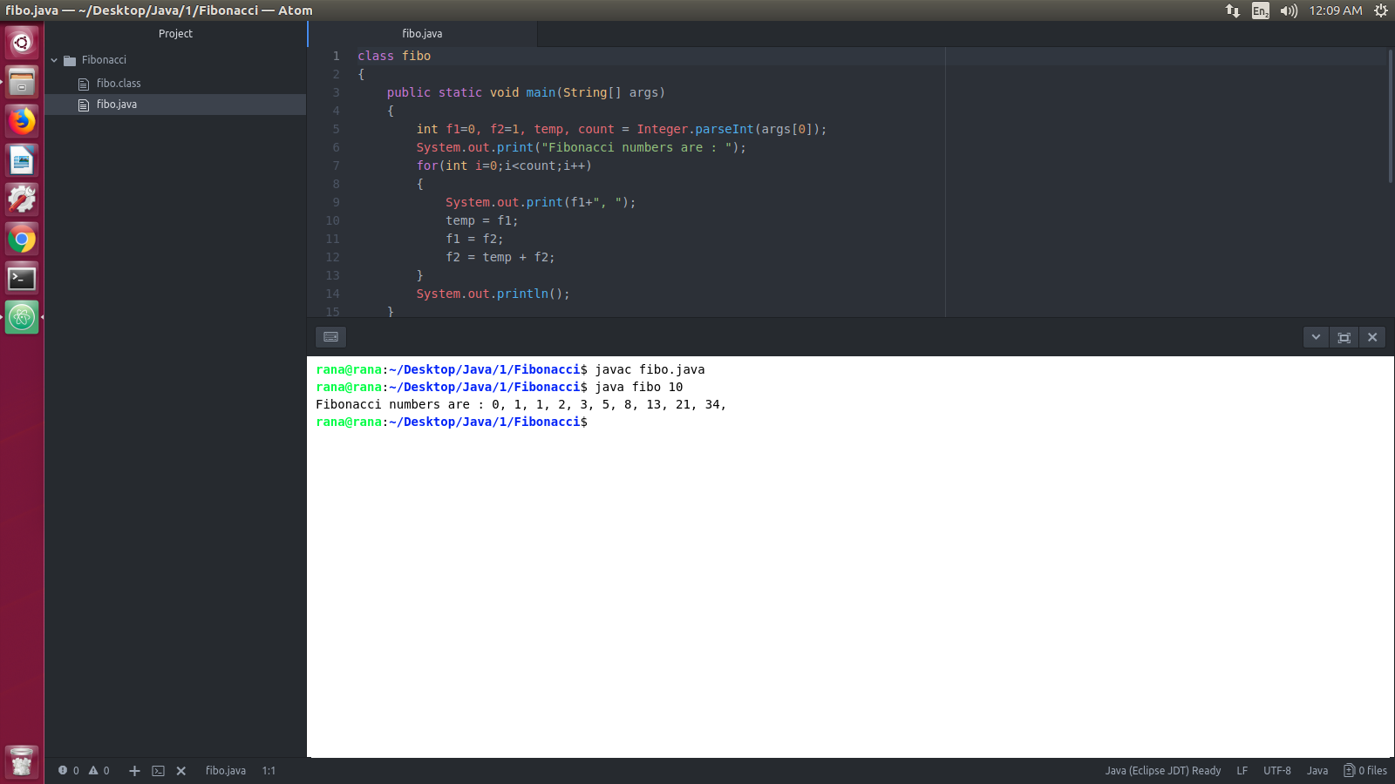**Screen-Shot:**

**Figure 1: Output**

**Assignment-2**

**Problem Statement:** Write a Java program to print the prime nos. upto ‘n’ number.

**Source code:** class prime  
{  
 public static void main(String[] args)  
 {  
 int i, j, n = Integer.parseInt(args[0]);  
 System.out.print("Prime Nos.: ");  
 for(i=2; i<=n; i++)  
 {  
 for(j=2; j<i && i%j!=0; j++)  
 {  
 continue;  
 }  
 if(i == j)  
 {  
 System.out.print(i+", ");  
 }  
 }  
 System.out.println();  
 }  
}

**Screen-Shot:**

**Figure 2: Output**

